2025 NACM National Honors & Awards Program Nomination Form

I have read all instructions (found by clicking on the “Nomination Instructions” button on Honors & Awards web page) before completing this form.

Hit the tab key to move from one space to the next. The completed nomination form and letter of recommendation must be submitted by February 7, 2025.
Please send your files as e-mail attachments to CaraC@nacm.org. Name the nomination form file as follows: CandidatesLastNameFI_HA.doc. Ex: AdamsJ_HA.doc. Contact Cara Crown with questions.

Nomination Category

(Choose only one per form)

Nominee Information

Name
Title
Company
Mailing Address
City, State, Zip
Business Phone
E-mail
NACM Affiliated Association

Nominating someone else? If so, please supply the following information about yourself:
Name
Title
Company
Mailing Address
City, State, Zip
Business Phone
E-mail
NACM Affiliated Association

Yes No - Is the nominee aware they are being nominated? Please note that in the final stage of this process the National Honors and Awards Committee may interview finalists by phone.
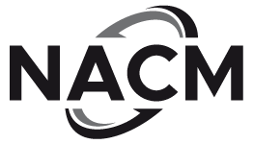

National Association of Credit Management ~ 2025

