2016 NACM National Honors & Awards Program Nomination Form

I have read all instructions (found by clicking on the “Application Instructions” button on Honors & Awards web page) before completing this form.

Hit the tab key to move from one space to the next. Completed nomination forms should be submitted with the information requested in the instructions and must be received by January 22, 2016.
Please send your files as e-mail attachments to CaraC@nacm.org. Name the nomination form file as follows: CandidatesLastNameFI_HA.doc. Ex: AdamsJ_HA.doc. Contact Cara Crown with questions.

Nomination Category

(Choose only one per form)

Nominee Information

Name
Title
Company
Mailing Address
City, State, Zip
Business Phone
E-mail
NACM Affiliated Association

Nominating someone else? If so, please supply the following information about yourself:
Name
Title
Company
Mailing Address
City, State, Zip
Business Phone
E-mail
NACM Affiliated Association

Yes No - Is the nominee aware they are being nominated? If yes, we reserve the right to contact the nominee during the initial stages of the review process to request information or clarify details. Please note that in the final stage of this process the National Honors and Awards Committee will interview finalists in each category by phone.

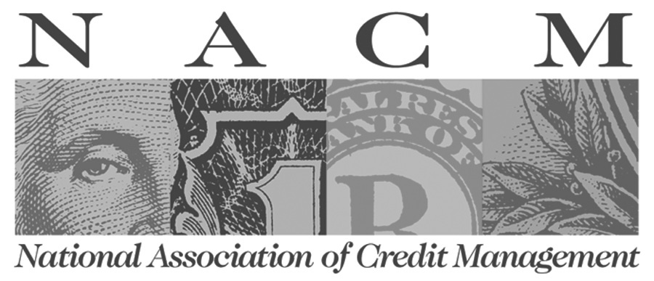
National Association of Credit Management ~ 2015-16

